Responding to a Critical Incident
Club crest

Club Name

GAA
Critical Incident Response Plan
Version 1.0
Tel:
● FB ● Twitter @

Reader Information
Title: | (Name) GAA Critical Incident Response Plan
Purpose: | This policy establishes clear, appropriate and safe guidelines for clubs outlining what to do in the case of a critical incident.
Author: | Critical Incident Response Team – (Name) GAA
Publication Date: | April 2021
Review Date: | April 2022
Target Audience: | Critical Incident Response Team
Copies of this plan held by: | (Club Chairman)  (Club Secretary)  (Health & Wellbeing Officer)  (Children’s Officer)  (Media & Family Liaison Person)  (Health & Safety)  (Club Member)  Copies also held by Juvenile & Camogie Committees
Contact Details: | Health & Wellbeing Officer  (Name) GAA  Ph:  E-Mail:

Version & Review Summary
Version | Owner | Author | Publish Date
1.0 | (Name) GAA | (Name) CIRT | Month 2021

Critical Incident Response Plan Team – (Name) GAA

Lead Liaison Person: | Health & Wellbeing Officer | Alternative Liaison: | Club Secretary
Name: |  | Name:
Contact No: |  | Contact No:
Alternative No: |  | Alternative No:
E-Mail Address: |  | E-Mail Address:

Support Team:
Name: | (Club Chairman) | Contact No:
Name: | (Children’s Officer) | Contact No:
Name: | (Health & Safety) | Contact No:
Name: | (Member) | Contact No:

Media Liaison Person:
Name: |  | Contact No:

Family Liaison Person:
Name: |  | Contact No: |  | 086 809 8598

Community/Support Contact Person:
Name: |  | Contact No:

Key Contact for Laois County Board:
Name: | Leona Conroy (County Health & Wellbeing Chairperson) | Contact No: |  | 086 340 3690

Key Contacts for GAA HQ:
Name: | Colin O’Regan (Croke Park Health & Wellbeing Manager) | Contact No: |  | 087 294 5705

CONTENTS
 | Page
CRITICAL INCIDENT RESPONSE TEAM CONTACT DETAILS | 4
INTRODUCTION | 6
WHAT IS A CRITICAL INCIDENT? | 6
PLANNING PROCESS | 7
ROLES OF SUPPORT TEAM | 7
DUTIES OF SUPPORT TEAM | 8
IMPLEMENTATION OF PLAN | 9
MEDIA RELATIONS | 10
SUPPORT & SIGNPOSTING | 11-12
RECOVERY | 13
REVIEW | 14
R1 – DEBRIEFING | 15
R2 - HANDOUT FOR COACHES/MENTORS | 16
APPENDIX 1 – GUIDELINES FOR DEALING WITH MEDIA | 17
APPENDIX 2 – SAMPLE LETTER FOR MEMBERS | 18
APPENDIX 3 – SAMPLE ANNOUCEMENT TO MEDIA | 19
APPENDIX 4 – GUIDELINES - DEATHY BY SUICIDE OF CLUB MEMBER | 20-21
APPENDIX 5 – LOCAL & NATIONAL SUPPORT CONTACTS | 22

INTRODUCTION
Sometimes a critical incident – one that overwhelms one’s natural capacity to respond – will arise leaving individuals or communities struggling to cope. GAA clubs and counties have proven themselves invaluable in supporting their members’ and communities in responding to an array of tragic and seemingly insurmountable situations.

However, sometimes our units need support in responding to critical situations too.

Preparing a critical incident response plan in advance will better prepare units for the challenges such situations may present. This resource is intended to:

• Reassure clubs of the importance of the natural support system they provide as a community organisation (in fact in most situations nothing more is required).
• Highlight some of the recommended best practises for responding to crisis situations by community organisations such as the GAA.
• Offer a toolkit from which units can develop their own critical incident plan highlighting key roles and responsibilities.
• Help identify appropriate local and national agencies/entities that units can turn to during crisis situations.
• Highlight the supports that are available through the GAA’s own structures.

What is a Critical Incident?
A critical incident is any event that is outside the range of usual human experience. It is an event that causes an unusually intense stress reaction which has the emotional power to overwhelm an individual’s usual ability to cope. It may impede people’s coping mechanisms immediately or in the future following the event. (GPA/GAA guidelines, 2014)

Examples of Critical incidents may include:
- Death or serious injury on or off the playing field
- Exposure to the aftermath of a road traffic collision eg; the accident scene, the victim(s)
- Personal loss or injury, real or threatened to a child or adult
- Being violently threatened
- Close encounter with death
- Suicide of a club member (This tragic situation can cause extreme distress and confusion for everyone involved. Guidelines developed by professional services highlighting the most appropriate responses are available (see appendix 4).
- A situation with excessive media interest
- A natural disaster or act of God
- Other incidents not covered above but which are associated with unusually strong emotional reactions.

PLANNING PROCESS
STEP 1
Nominate a designated liaison person and support team to oversee the plan…
- Designated person should be suited to the role. They should have an interest in this type of work and some particular skills (e.g. communication skills, calm approach, good coordinator)
- Nominate an alternative lead person in case designated person is unavailable
- Responsibilities attached to the various roles should be clearly outlined

It is important to involve club committee in the planning process, to ensure that they support the plan and are able to implement it in the event of an emergency. Clubs should identify members that are prepared to take on key roles in an emergency and should nominate one person to take responsibility for updating and reviewing the plan once it is in place.
The principles below apply to managing a wide range of incidents:
- it should be simple and straightforward to implement
- it should be known by all those having identified responsibilities within it
- it should be regularly reviewed, and critical information updated
- it should be held in a duplicate copy off-site in the event of fire/flood etc

ROLES OF SUPPORT TEAM
STEP 2
Outline the key roles involved….
These may include:
- Incident liaison person (e.g. club chairperson, health & wellbeing officer)
- Garda Contact
- Media relation person (e.g. club chairperson, club PRO)
- Community/Support agency contact
- People named in the plan with responsibilities should provide 24 hour contact information

It is important that individuals understand their role within the Critical Incident Response Plan. There are a number of specific responsibilities, which need to be identified and assigned to individuals.

DUTIES OF SUPPORT TEAM
STEP 3
Highlight potential duties when responding to a critical incident…
These may include:
- Liaison with those directly affected and if required outside agencies or services
- Obtain information and record actions taken
- If necessary manage any media relations/enquiries (See R-6 in the Appendix for a
sample media notification message)
- Monitor the club’s response throughout the process
- If necessary organise a debriefing meeting for club members or specific groups (e.g. coaches, players, juveniles, parents). Please see R-10 and R-11 in the Appendix for advice relating to debriefing and what may be involved.

Lead Liaison Person:
- Alerts the Critical Incident Management Team of an incident and convenes a meeting of the team
- Coordinates the tasks of the Support Team
- Liaises with the bereaved family
- Liaises with the Gardaí
- Liaises with the County Board, GAA HQ
- Keep record of all phone calls, letters, meetings etc
- Responsible for privacy and confidentiality when needed
Media Liaison Person:
- Will draw up press statement, give media briefings and interviews (as agreed by CIRT and Club Executive Committee)
- Will coordinate the monitoring of communications relating to the incident.
- Ensures that information about deaths is checked out before being shared
- Liaises with agencies in the community for support and onward referral

Family Liaison Person:
- Co-ordinate contact with family
- Liaise with family of bereaved regarding plans for attendance at funerals etc
- Provide ongoing support to families affected by the incident – as appropriate
- Organise letter of condolence to the family from the club

Community/Support Contact:
- Will draw up press statement, give media briefings and interviews (as agreed by CIRT and Club Executive Committee)
- Maintains an up-to-date list of contact names and numbers for local community organizations.
- Liaises with organisations in the community for support.
- Provides information on an on-going basis where appropriate.

CRITICAL INCIDENT RESPONSE TEAM CHECKLIST:

- Always consult with those affected to see what level of support they want from the club, if any.
- Convene a meeting of the Critical Incident Response Team
- A General Practitioner (GP) should be recommended as the first point of contact if an individual needs help.
- To ensure consistency of message, only one person should deal with any media inquiries.
- Be mindful of social media and ensure that all information put on social media is accurate and approved by those affected.
- If there is a club match scheduled always check in with those involved to see how they would like the club to manage fulfilling the fixture.
- Where will the plan be kept and are people aware of this?

IMPLEMENTATION OF THE PLAN:
Incident reported to Club Chairperson
Club Chairperson reports incident to Lead Liaison Person
Lead Liaison Person Alerts CIRT and convenes a meeting

CRITICAL INCIDENT CHECKLIST:

- ALWAYS consult with those affected to see what level of support they want from the club, if any.
- Convene a meeting of the Critical Incident Response Team
- A General Practitioner (GP) should be recommended as the first point of contact if an individual needs help.
- To ensure consistency of message, only one person i.e the Media Liaison Person should deal with any media inquiries.
- Be mindful of social media and ensure that all information put on social media is accurate and approved by those affected.
- If there is a club match scheduled ALWAYS check in with those involved to see how they would like the club to manage fulfilling the fixture.

Key Points - It is important to remember that individuals and families are central and must be heard first.

Key Point - Remember that the role of the club is primarily to act as a sign-posting service to the supports that are available. Boundaries should be appreciated and getting the balance between what a voluntary entity can offer as opposed to what professionals can is
important. Do not take on too much.

MEDIA RELATIONS
Key things to consider:
- Agree all social media/press statements with your Media Liaison Person & Club PRO
- Ensure that all information to the media comes through a single reliable source
- Please use templates provided (see Appendix 2 and 3)
- Provide as much information as reasonable.

You may find it helpful to prepare some basic information about the club which could be used in the event of a major incident.
Do’s & Don’ts for Media Liaison Person:

DO NOT give any fact unless you are certain it is correct
DO NOT say "NO COMMENT" - it can be taken as a negative answer which could be inaccurate and lead to difficulties later
DO NOT be afraid to say "I DO NOT KNOW"
Take time to prepare a statement (please refer to Appendix 2 and 3 for media templates)
DO inform the Media Outlets of any development which may assist them and of any journalist you suspect of acting inappropriately.
DO refer to APPENDIX 1 for further guidelines with dealing with media after a critical incident

RECORD KEEPING:
It is important that accurate written records are kept, and that no piece of information about either the planning or the response to the incident is lost. Note all relevant facts in chronological order and stick to the FACTS. The records should be retained after the incident for future reference.
Each member of the team involved in dealing with the incident should log telephone calls made and received and tasks carried out. In an incident, things happen very quickly and it is unlikely that you will remember all the people you have spoken to and actions you have taken unless you write everything down.

CONFIDENTIALITY:
The club is conscious of its responsibility to protect the privacy and good name of people involved in any incident and will be sensitive to the consequences of any public statements.

SUPPORT & SIGN-POSTING:
STEP 4
Identify relevant resources and services available to the club…
- Each community/county will have various agencies/support groups that may be called on during or after specific incidents. These should be identified and contact details recorded in your plan. When making contact you should inform the external party that you intend including them in your contacts list.

Key Point - It’s important to remember that the GAA will usually be just one entity playing a part in any response to a critical incident.

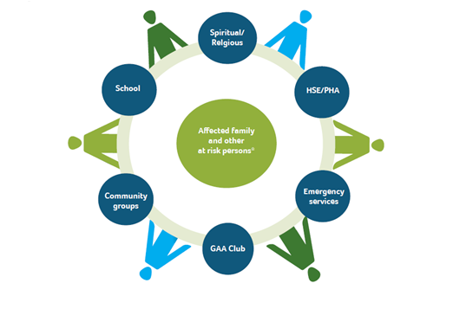

Key Point - Remember that the role of the club is primarily to act as a sign-posting service to the supports that are available. Boundaries should be appreciated and getting the balance between what a voluntary entity can offer as opposed to what professionals can is important. Do not take on too much.

WHO REQUIRES SUPPORT?
In addition to the individuals directly affected, other ‘at risk’ persons are amongst those most likely to suffer distress as a consequence of an incident. These may include those who:

• directly witnessed death/injury/violence as part of the incident
• are uninjured, but were at greatest risk
• are siblings of those immediately affected
• may blame themselves and/or those who may be blamed by others
• are experiencing instability at home
• have learning difficulties
• have pre-existing emotional and behavioural/mental health difficulties
• are vulnerable due to cultural and/or language difficulties
• have previously suffered bereavement or loss
(GAA/GPA Critical Incident Response Information and Guidelines, 2014)

WHERE TO FIND IMMEDIATE SUPPORT:
Please refer to APPENDIX 5 for further local/national support groups.
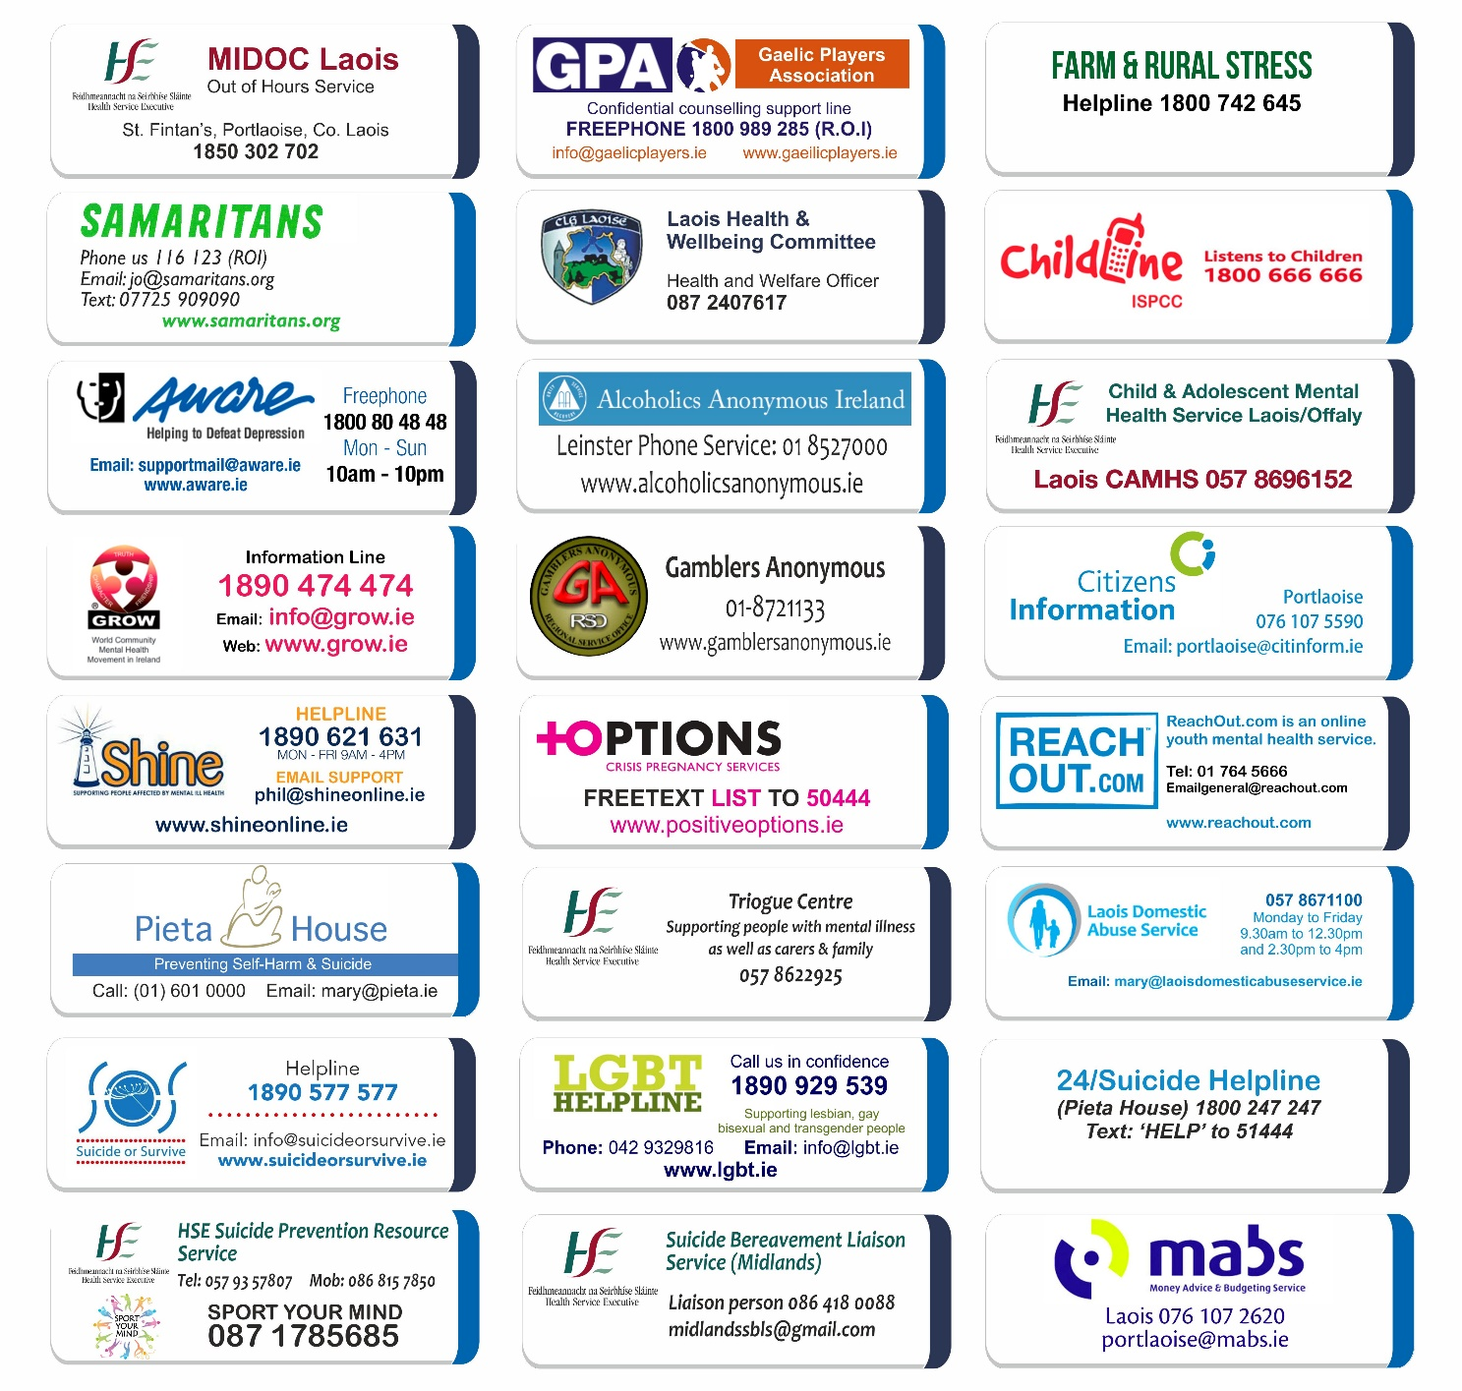

RECOVERY:

When the incident has passed the club can begin the recovery process. The Lead Liaison Person and the Support Team should continue to work with the relevant support groups and agencies.
There may be formal inquiries or even Gardaí investigations into the incident, which may continue for some time, and require the cooperation and support of club committee members
POST-INCIDENT Checklist:
As soon as possible after the incident:
- Liaise with family of bereaved regarding plans for attendance at funerals etc
- Liaise with members regarding plans for attendance/representation at funeral services
- Arrange debriefing meetings for the Club Committee and CIRT
- Arrange debriefing meetings for coaches/mentors
- Consider the need for individual or group support
- Help affected members to come back to club
- Initiate a review of the Critical Incident Response, evaluating the club’s response and feeding in any lessons learnt
- Where will the plan be kept and are people aware of this?

In the longer term:
- Consult and decide on whether and how to mark anniversaries
- The impact of some incidents can continue for years, so thought may need to be given to ongoing identification and support measures for both support team, members and players

REVIEW:
STEP 5
Review the plan annually or following a critical incident…
- After managing a critical incident it is good practice to review the procedures and amend the plan in the light of experience and lessons learned. This should also be carried out annually regardless of an incident having happened.

Checklist for reviewing the critical incident response plan

- Have key roles been clearly identified and tasks clearly outlined?
- Are personnel suitable?
- Is the contact list appropriate and complete?
- Are materials such as press releases, letters readily available, for adaption to suit the particular circumstances?
- Are telephone numbers on contact lists up-to-date?
- Where will the plan be kept and are people aware of this?
- Has each member of the Critical Incident Team a personal copy of policy and plan
- Has a date been set for a review of the plan?

R1 - What a debriefing session is and involves

Debriefing
Debriefing allows those involved with the incident to process the event and reflect on its impact.
(Davis, 1992; Mitchell, 1986).

A debriefing session will have three main objectives.
1) Allows members to take time out to speak freely about the incident,
2) It helps restore a form of ‘normality’ to members/the club which has been involved in a
critical incident.
3) An opportunity to provide members/the club with information on additional support
services if required.

A debriefing session may take the form of a meeting/gathering and can sometimes be useful to
have an independent person not directly involved in the incident to facilitate discussions.

A debriefing session may look at the following issues:
• What actions/interventions did the club/members take? e.g. was club rooms opened to allow community to come together? Was there information/support services information provided to members/community?
• What worked well?
• What could have worked better?
• Next steps – Record learning
• Forward Planning - Anything that needs to be put in place?
• Does the critical incident plan need amending?
• Are there any gaps?

R2 - Handout for Coaches/Mentors - Squad session following news of a critical incident

Normally, the coach/mentor who knows the players best should be the person to inform them of the events and lead the classroom session. Players, especially juvenile ones, generally feel safe and secure with someone they know. If the individual(s) feels uncomfortable with this role another club member may work with them and share the task, or outside support may be brought in.

Coaches/mentors/officers should have the opportunity to opt out of this work if they feel unable to handle it and other arrangements should be made for the squad/group of players. The aim of the session is to break the news to give the players an opportunity to discuss what has happened and to express their thoughts and feelings in a secure environment. The facilitator needs to listen and be empathic.

The session needs to be tailored to the age and developmental level of the group. The outline of the session is as follows:

Step 1: Giving the facts and dispelling rumours
Tell the players in a calm, low key and factual voice:
- What has happened
- Who was involved
- When it happened
- The plan for the day
Step 2: Sharing stories and allowing and encouraging the sharing of thoughts and the expression of feelings
Step 3: Normalising the reactions
Tell the players that they will all react differently to what has happened and that there is no right or wrong way. Let the players know there are supports in place if need and signpost them to these agencies if required.
Step 4: Worries (for younger players)
Please use age-appropriate language to
Step 5: Empowerment
Help the players to identify strategies that they might use to help manage their reactions. For example, talking to family and friends, getting enough sleep, exercise may all help.
Step 6: Closure
End the session by focussing on the future. Depending on the nature of the incident, help the group decide what they would like to do about various issues, e.g., what to do about the person’s jersey, about writing cards or letters. Reiterate the message that their reactions are normal responses to abnormal circumstances.
Step 7: Free Time
After the discussion the coach may want to allow the players’ some play time on the pitch or free time together, depending on the age.
Step 8: Recovery
• Members should be encouraged to resume club activities
• Help members to identify or establish some supports; help them to identify who they go to for different kinds of help
• Use opportunities which arise within training, where coping and support can be reinforced
• Members could be encouraged to discuss how to avoid future crises and lessons learnt from their experiences

Appendix 1
Guidelines for dealing with the media following a critical incident

Following a critical incident in which people have died, press interest in survivors and bereaved families can be intense. There are rules and standards the press should follow. All members of the press have a duty to maintain the highest professional standards. The Independent Press Standards Organisation (IPSO) is charged with enforcing the ‘Editors’ Code of Practice’.

Individuals are under no obligation to speak to the media. If someone doesn’t want to speak to them - tell them.

When speaking with the media the following are some helpful tips;
- always make a note of the journalist’s name and contact phone number at the outset
- consider appointing somebody as a spokesperson for family - this might be a relative or friend, or your solicitor - some support groups have appointed media liaison people who will field questions on behalf of the support group
- don’t do anything in a hurry, whatever the journalist says about deadlines
- ask what they want to talk to you about in advance
- ask them to write down the questions they want to ask you in advance
- give yourself time to think about what you want to say
- write down your answers
- ask the journalist to ring you back at a specified time
- ask if you can see what they wish to quote from you before it goes to press - they may not do this, but it will alert them to your concerns about what they are going to publish
- never say anything ‘off the record’ unless both you and the journalist have a shared understanding of what this means
- remember that a journalist is entitled to report anything you say, so don’t mistake them for counsellors or friends
- bring the conversation to a close if you are uncomfortable

Sometimes journalists will ask for photographs of you, your loved one, and your family. You may wish to provide these, but remember that you are under no obligation to do so. If you do, ensure that you have a copy and ask for the photographs and any other personal items that you pass on to be returned.

Appendix 2
Sample support letter for members

Support Service for __________________ Club/County members

We are all in shock from the untimely death of ____________________.

To lose a loved one like, a dear friend and team mate, is one of the most difficult life experiences you will have to face. When the death is sudden and tragic, family and friends must cope with the sadness of their loss plus all their additional heightened feelings like confusion, questioning of self, anger and coming to terms with his death.

Should you wish to speak to someone in confidence about how you feel or if you need help or guidance to come to terms with death, please call: Samaritans, official helpline of the GAA and available 24-7, on their free-phone number 116 123.

The above is a confidential service available to you and we encourage you to avail of it and call, if you need to talk to someone. Equally, should you know of any of your friends or colleagues, who are struggling to come to terms with __________________ death please encourage them to call also, or talk to a loved one about their feelings.

We also ask you to keep an eye out for each other, not to be shy or embarrassed about asking for help and to talk to and support each other during what is a very difficult time for us all. If there is anything we can do to help and support you please let us know. We will get through this tragic time together.

__________________________,
Chairperson,
on behalf of the __________________ Club Committee.
Phone: (insert your number here if you feel it is appropriate for any additional enquiries)

Appendix 3
Sample announcement to the media

PLEASE NOTE: This can be used as a template by clubs to be emailed, faxed or given to the media. It may help to decrease the number of media calls and callers to the club. In some instances it is not appropriate to provide names or information that might identify individuals.
This announcement will need to be changed based upon confidentiality issues, the wishes of the affected family and the nature of the incident.

Template 1:
My name is (Name) and I am the (Role within the club) of (Name) club. We learned this morning of the death of (Name). This is a terrible tragedy for ________________ family, our club and our community. We are deeply saddened by these events. Our sympathy and thoughts are with (Name) family and friends.

(Name of person) was a member of (Name) club and will be greatly missed by all who knew him/her. We have been in contact with his/her parents/family and they have requested that we all understand their need for privacy at this difficult time.

Offers of support have been pouring in and are greatly appreciated. Our club have implemented our Critical Incident Response Plan. The club has been open to members, to support them and to offer them advice and guidance.

We would ask you to respect our privacy at this time.

Thank you.
Chairperson

Template 2 (Social Media Statement):
(Club Name) wishes to express its profound sadness and shock at the tragic passing of (Name). This has brought great sorrow and grief across the community. We extend our deepest sympathy and condolences to ____________ family, extended family, and many friends.

As a mark of respect our club activities will be postponed and our playing fields silent until further notice. Details of funeral arrangements will be published when they become available.

The club will be making no further comment at this time.

Ar dheis De go raibh a anam dilis.

Appendix 4
Good Practice guidelines following the death by suicide of a club member

The term "suicide" should not be used until it has been established categorically that the member’s death was a result of suicide. The phrases "death" or "sudden death" may be used instead.

The following is a guide how the club can support the bereaved family, club members and players.

Family:
- The Lead Liaison Person should contact the family to establish the exact facts and the family's wishes about how the death should be described.
- Organise a home visit by a member of the Club Committee
- Consult with the family regarding the appropriate support from the club e.g. at the funeral service.

Club Officials & Members
- Convene a Critical Incident Response Team meeting to brief team on the above details.
- Help Coaches/Mentors to prepare for breaking the news to players. Please refer to Rx for further information re this.
- Decide on the strategy to deal with queries from members/players. Prepare a letter/statement setting out the facts and how the club is dealing with the events.
DO’s:
- Acknowledge the death and Respect that some families may choose not to describe the death as suicide
- Acknowledge a wide range of feelings.
- Try to get the balance right regarding continuing with normal club activities
- Keep an eye out for vulnerable people and sign-post where necessary to local/regional support services
- Anticipate sensitive dates on calendar
DON’Ts:
- Do not focus only on the positive
- Be careful how you pay respects – DO NOT do commemorative matches, naming of trophy, number on shirts etc. Avoid activities that glamorise or glorify suicide.
- Ask members to not over-indulge in alcohol, caffeine, or other substances around the time of the funeral and immediately afterwards
- Keep an eye out for vulnerable people and sign-post where necessary to local/regional support services
- Anticipate sensitive dates on calendar

Responses:
After a death by suicide, clubs have found the following short-term and medium to long-term
responses helpful.

Short-term
Right after a suicide those affected often look for the following:
- Information: Identify key supports that are available locally and regionally to provide advice, support and care at this time.
- Support: The first gathering of the team after the funeral, for example, the first night back at training, may be a difficult time for everyone. Coaches have found it helpful to break the team up into small groups and allow some time to talk about their deceased team member. Coaches or team leaders should seek the help of local support services if they feel necessary. Some coaches may not feel comfortable in preparing for such a gathering.
The following topics are usually addressed:
• How to support people who are grieving at this time.
• Looking after yourself during this traumatic time; and
• What to look out for, say and do if you are worried about someone else.

Medium to long-term
- Policies & Procedures: Clubs are encouraged to develop and implement policies and procedures on suicide prevention as well as other broader areas such as drug and alcohol use i.e. GAA’s Alcohol and Substance Abuse (ASAP) Programme which aims to prevent alcohol and drug problems taking hold in clubs.
- Training: Clubs find it helpful to offer training and skills development to coaches and team leaders. It may be useful to initially look at some form of resilience programmes/training that will help coaches/members. There is also the opportunity to look at putting in place suicide awareness training (LivingWorks Start, safeTALK and ASSIST) in the longer term.

Other situations to note

Discovery of a suicide on club grounds
The following steps should be taken with the discovery of a suicide on sports grounds:
• Give or ask for first aid if there is any possibility the individual may be saved or resuscitated.
• Contact the emergency services IMMEDIATELY
• Leave the scene untouched
• Avoid disturbing any evidence
• Keep onlookers away
• Write down the names of all the staff and team members who witnessed the event or discovered the suicide
• Tell the closest relative – the Gardaí usually do this

Suicide notes on clubhouse
Once you become aware of the existence of a suicide note, for example, a paper note or a suicide message written on a club house wall, leave it untouched and immediately tell the Gardaí. After the personal and legal needs of family and Gardaí are met, the club’s CIRT will decide when and how best to remove the note.

Appendix 5
Local & National Support Groups

GAA CONTACTS:

Contact | Contact Person | Contact Details
Club Chairperson

Club Secretary

Club Health & Wellbeing Officer

Club Children’s Officer

Club PRO

County Health & Wellbeing Chairperson | Leona Conroy | 086 3403690  chair.hwc.laois@gaa.ie
County Children’s Officer | Seamus Lahart | 087 6628132
County PRO | Paul Dargan | 086 8650714  pro.laois@gaa.ie
National Children’s Officer (Croke Park) | Gearoid O Maoilmhichil | 01 8363222 or  nationalchildrensofficer@gaa.ie
Community & Health Manager (Croke Park) | Colin Regan | 087 2945705 or  Colin.regan@gaa.ie

USEFUL SERVICE CONTACTS IN YOUR AREA:

Contact | Contact Person | Contact Details
Accident & Emergency | Portlaoise Hospital | 999 or 112  057 862 1364
Gardai | Portlaoise Branch | 999 or 057 867 4100
GP/Club Doctor | Portlaoise
Local GP or MIDOC Out of Hours GP Service | Portlaoise | `  1850 302 702
Parish Contact

Order of Malta | Marie Carroll - Portlaoise | 087 6964958
Citizens Information Centre | Portlaoise Branch | 057 868 2292
Newspaper/Media Outlets | Leinster Express  Laois Nationalist  Midlands Radio 3 | 057 862 1666  057 8670216  057 9351333
Bereavement Support Services | Portlaoise Parish | 087 9878300  057 862 1364 (out-of-hours)
Samaritans | Samaritans | 116 123
HSE Suicide Bereavement Liaison Service Co-Ordinator | HSE | 086 418 0088
Midland Living Links | Bereavement Listening & Support Service | 086 1600 641
24/7 Suicide Helpline | Pieta House | Helpline: 1800 247 247  Text: ‘HELP’ to 51444
HSE Helplines | Free 24/7 Crisis Text Service  Mental Health Website Advice | Text: 50808  www.yourmentalhealth.ie
HSE Resource Officer for Suicide Prevention | Josephine Rigney  (Longford, Westmeath, Laois & Offaly) | Ph: 086 815 7850  E-Mail: Josephine.rigney@hse.ie

Please refer to http://read.digitaleditions.ie/i/532758-responding-to-a-critical-incident to get a FULL copy of the GAA’s Guidelines for Responding to a Critical Incident
Please go to https://www2.hse.ie/services/mental-health-supports-and-services-during-coronavirus/ for access to ALL local/regional/national support groups and services contact details

